Part I- Part II to be posted later tonight.

1. A firm produces a soft drink using two ingredients, sugar (S) and bubbly water (B) in fixed proportions: 6 tablespoons of sugar per 12 oz of bubbly water.

a) What is the production function? Does this production function exhibit constant, increasing or decreasing returns to scale?

What is being described here is a fixed proportions production function:



If, for example, we mix 6 units of S and 12 units of B, we get:

 unit of the soft drink

Let’s multiply both of the inputs by some number and see by what factor the output increases. More practically, we need to compare  to :



So, we have a constant returns to scale production function (CRS)

b) Write down the firm’s cost minimization problem and solve for the conditional factor demands.

Assume the price of a tablespoon of sugar is **Ps** and the price of an oz of bubbly water is **PB**. The firm wants to minimize its cost (**PS** S+ **PB** B) subject to producing some desired quantity of units (Q). We say “conditional” factor demands, because these demands are conditional on how much output you choose to produce (i.e. Q). We need to solve:



We need two conditions: tangency and feasibility. Now, since one of the functions is the fixed proportions function, then we can’t really have tangency but in its place we will have:

 (1)

The feasibility is the constraint:

 (2)

We now have two equations with two unknowns. A good idea would be to solve them ☺ So, substitute (1) into (2) to get:



And thus 

So the conditional factor demands are:



2.. Sam’s Trucking Co hauls freight in the US. Sam’s Trucking is a perfectly competitive firm in

the trucking industry where the price of hauling a ton of freight from NY to Boston is $250. One

of the most expensive inputs in the trucking business is the price of diesel fuel, PD. For each ton

carried from NY to Boston 100 gallons of diesel is used so the fuel costs of hauling Q are (100Q)PD. Sam’s Trucking Co has a variable cost curve VC(Q)= Q^2+(100Q)PD (= Q2+ fuel

costs). In the questions below specific values of PD will be set. Sam’s Trucking Co **has no fixed costs** of production.

a) Revenue: He will make 250Q. Marginal revenue is the derivative so 250.

b) VC=Q^2+100QP_D => Q^2+200Q. MC=d(VC)/d(Q)=2Q+200

c) We need MC=MR (profit maximization condition) so 250=2Q+200 =>Q*=25. π=25*250-25*25-200*25=25*25=625

d) We only change the variable cost (profit maximizing condition does not change!!!) so now we have vc=Q^2+100*3Q with high diesel prices or Q^2+100*1.5Q if diesel prices are low. These give profits of -1875 and 1875, respectively.

e) The point of this asset is that it is similar to insurance, but with a more specific structure. (Those of you who have taken any sort of financial class may recognize this as a classical call option on a commodity, the commodity being the prices of diesel.) Unlike options trading, this sort of thing is what options were originally intended for.) The asset is worth $1 in the case of high Diesel prices and nothing in the case of low diesel prices. Why? The asset is the right (but not obligation) to buy Diesel at its stated price. So if diesel is expensive, then you are allowed to buy at $2, which saves you a whole $1, so the value is $1. On the other hand, if diesel is low, you *could* use the asset to buy diesel at $2, but it would be *cheaper* to buy at the market price, and so the asset itself is worthless. (Notice it is not negative since you aren’t forced to buy at the more expensive price in that case.) Taking the expectation based on probability of the outcome, we have 1/3*1+2/3*0=1/3.

f) All you have to do is figure out what would give the same profit in both cases (ie this question is *not* asking you to maximize expected profit.) To do this, we just consider the variable costs in each state (as revenue will be the same) and set them equal. So suppose you buy x assets (ie the right to buy x gallons of diesel at $2). Then your variable cost in the case of a high diesel price (ie the asset saves you a dollar) is as follows: Q^2+Q((100-x)*3+(x)*2)+Qx/3. The 100-x and x terms come from the fact that for any Q you want to produce, you can use the asset for x of the 100 gallons per unit required and have to buy the diesel for the remaining at the market price. The final term (x/3) is the fair price of the asset times its quantity, ie 1/3*x. On the other hand, if diesel price is low, you will buy all diesel at the market price, but still have paid the price of the asset, so vc becomes Q^2+100Q*1.5+Qx/3. Set these equal and cross out the Q^2 terms so we get

Q(100-x)*3+2xQ=150Q =>x=150. (Note this is weird in that you are buying more options than you would exercise! So this in fact would not be expected profit maximizing. Expected profit maximization would result in imperfectly hedged profits- which might be better, depending on risk aversion, but we don’t care about that in this problem.) Notice that plugging this in, we get variable costs of Q^2+200Q in both cases. Then profits work out to be 250*25-25*25-200*25=625 in both cases.

3. Bob’s Basil Farm uses both premium organic manure (x) and compost (y) to fertilize the basil plants. The production function of Bob’s is given by  where both manure (x) and compost are measured in cubic yards and Q is measured in pounds of basil. The price of manure is $64 per cubic yard and the price of compost is $1 per cubic yard. Bob’s has no overhead (fixed costs).

For parts (a) – (b) below assume that Bob’s stock of compost is fixed in the short run. In particular Bob has only 8 cubic yards of compost. This results in fixed costs of $8.

a) In the short run what is Bob’s (compensated) demand curve for manure? What is his variable cost curve? What is his total cost curve?

With y fixed to 8, the production function becomes:



We can solve this to get x:



The costs are:



b) In the short run what is the marginal cost curve of Bob’s Basil Farm? What is the average cost curve? What is the optimal size of the firm? Illustrate the short run marginal and average cost curves below.





3.17

Short-run AC curve

Short-run MC curve

Q

For parts (c)- (d) below assume that Bob’s stock of compost is variable in the long run.

c) In the long run what is Bob’s (compensated) demand curve for manure? What is the (compensated) demand for compost? What is the variable cost curve? What is the total cost curve?

Bob needs to solve the following program:



The first order conditions are:

 (1)

 (2)

Substitute. (1) into (2) to get:



Now, substitute this result back to (1) to get 

To summarize:



The costs are:



d) In the long run what is Bob’s marginal cost curve? What is the average cost curve?



Finally let’s compare the average cost curves in the short and long runs.

e) At what quantity is the demand for compost equal to 8? What must be true about the short and long run average costs at this quantity? Illustrate the long run average cost curve in your diagram for part (b).

Let’s start by first making sure we understand what the average cost (AC) curve is telling us. The AC curve is showing for each quantity Q, the cheapest average cost you can achieve while making sure you produce Q units of output. There may be other ways to produce Q units, but the y-coordinate of the AC curve corresponds to the average cost of the cheapest way.

Now, think about the short-run vs. the long-run for a minute. In the short-run, one of the inputs is fixed (i.e. one of my hands is tied) whereas in the long-run I am free to choose both inputs as I desire to make the cost as cheap as possible. One would thus expect the short-run AC curve to lie above the long-run AC curve (maybe touch it in a few points, but never go below) because whatever cost I can achieve with one input fixed (short-run), I will surely do no worse by being allowed to use both of my inputs to optimize the cost (long-run).

Let’s go back to the question. In the long-run, the demand for input y (compost) is 8 if I need to produce 4 units of output (). In other words, where I can choose both of my inputs freely, if I need to produce 4 units of output, y must be set to 8. In the short-run, y is fixed to 8, so if I want to produce 4 units of output as cheaply as possible in the short-run, I can actually get the same cost as in the long-run (because y happened to be fixed to the optimal long-run value for Q=4 anyways).

For other values of Q, however, the optimal y will not be 8, and so whatever average cost I can achieve in the short-run, will be higher (more expensive) than what I can achieve in the long-run. The two curves are thus tangent at Q=4:

4

Short-run AC curve

Long-run AC curve

Q

4.) Hands nail salon

a) The expenditure minimization problem is as follows: min wL+rK st (f(L,K)>=Q))

write **L**=16L+4K-(20K^(1/4)L^(1/4)-Q). Take first order conditions: w/r=(∂Q/∂L)/(∂Q/∂K). After some basic algebra this simplifies to K=4L. Then plug this into the output function. Q=20*(4L)^(1/4)*L^(1/4). If you isolate L (ie divide by 20 and 4^(1/4), then square) you get L=Q^2/800. This means K= Q^2/200. These are our compensated demands (and give the expenditure minimizing levels of input for any desired output.) Then the cheapest way to produce Q costs 16*Q^2/800+4Q^2/200=.04Q^2.

b) AC=(.04Q^2+64)/Q=.04Q+64/Q. MC =d(AC)/dq= .08Q. Optimal scale has AC=MC and gives .08Q=.04Q+64/Q so .04Q^2=64 and thus Q_opt=40. To illustrate the two cost curves, make the normal picture: AC goes down and then up, mc is a line, and they cross at minimum of average cost. We have economies of scale when average cost is decreasing (ie Q<Q_opt) and diseconomies of scale when average cost is increasing (Q>Q_opt).

c) set MC=MR: .08Q=4 => Q= 50. Calculating profits at this price: 50*4-64-.04*50*50=36>0 => supernormal. To illustrate profits, draw the rectangle between where q=50 meets AC graph and the line y=4.

d) It is not market clearing, and the easy way to see this is to note that at market clearing in a perfect market, Q*=Q_opt which is not the case here (Q_opt=40 and Q*=50). Then we can calculate P by finding the price that induces the firm to set Q=Q_opt=40 ie p is MC=.08*40= 3.2. Then find the Q_demanded: 9200-3.2*400=7920. Solve for number of firms by realizing that since all cost structures are the same, they will all choose to supply the same (40). So 7920/40=198 firms.

d)

5.) You are asked to do an analysis of the textile industry. Given the current production techniques of a typical manufacturer the number of rolls of fabric produced by a man-hour of labor (the only variable input to production) provided the total number of hours of labor is less than or equal to **10** per day is given by the following production function: **Q = L.** For hours of labor in excess of **10** per day the production function is: **Q = 10 + (L – 10).5**

1. Illustrate the (daily) production function for a textile manufacturer. In your diagram indicate the region of constant returns to scale production and the region of decreasing returns to scale.

**Answer:**



The cost of labor is $2 per hour. In addition to labor costs there are materials costs of $100 per roll and fixed costs of operation of $230 per day. Labor and materials are the only variable costs of production.

1. What is the demand curve for labor? Given your demand for labor what is the cost curve of labor? What is the variable cost curve of a textile manufacturer? What is the total cost curve? What is the marginal cost of any unit up to the 10th unit? What is the marginal cost of any unit after the 10th unit? What is the average cost of any unit up to the 10th unit? What is the average cost of any unit after the 10th unit?

**Answer:**













1. Illustrate the marginal and average cost curves. Show that the quantity of 15 rolls minimizes the per-unit costs of production. What is the average cost of 15 rolls? Indicate the minimum of the average cost curve and the optimal size of the firm in your diagram.

**Answer:**





1. What is the supply curve for the typical firm? If the price in the market is $160 then how much would the firm want to supply to the market? Would the firm be earning super-normal, normal or sub-normal profits at this price? Illustrate the profits in an average cost and marginal cost curve diagram.

**Answer:**





1. You estimate that the typical firm in this industry is producing 12 rolls of fabric per day. What do you predict will happen in this industry? Will firms enter or exit the industry? Will the price rise or fall?

**Answer:**



1. If the estimated demand for fabric is **QD(P) = 390 - P** where the quantity is measured in numbers of rolls per day then what will be the long run price and number of rolls traded of fabric? How many firms will there be in the industry?

**Answer:**



1. If the price of materials rises by 10% then what will be the impact of this price rise on the variable costs of the firm? What will be the impact on the marginal and average costs of the firm? Illustrate the new marginal and average cost curves in a diagram. Include the original average and marginal cost curves in your diagram. What will be the new optimal size of the firm? Indicate the optimal size of the firm in your diagram.

**Answer:**





6. Suppose that the daily total cost curve for a typical lens grinder is **C(Q) = .2Q2 + 8Q + 80**. Quantity (Q) is measured in lenses per day. Suppose that demand per day for lenses is **QD(P) = 220 – 2P**.

1. What is the average cost curve for a typical lens grinder? What is the marginal cost curve? What is the optimal scale of the lens grinder? Illustrate the average and marginal cost curves.





*optimal scale*:





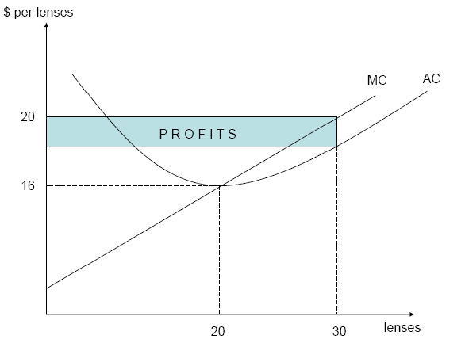

1. What is the supply curve of a typical lens grinder? If there are 6 firms in the industry each of which has the typical cost curve then what is the industry supply curve of lenses?





*however, firms produce only when price > min AC(Q), so the supply curve is:*





*then the industry supply curve is:*



1. If the market is perfectly competitive then what will be the market clearing price and quantity traded in the lens market in the short run? Illustrate your answer in a supply and demand curve diagram.



*because P* = 20 is greater than min average cost, firms will supply a positive quantity, so the market-clearing price and quantity traded will be P* = 20, Q* = 180.*

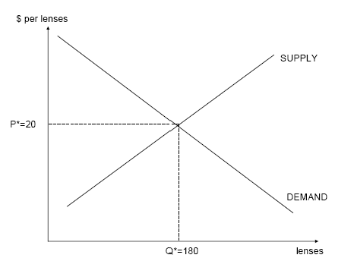

1. How many lenses will each firm supply? What is the elasticity of the demand curve that an individual firm faces? Illustrate your answer in a diagram of individual firm supply curve and individual inverse firm demand curve.



 *(perfectly elastic*)

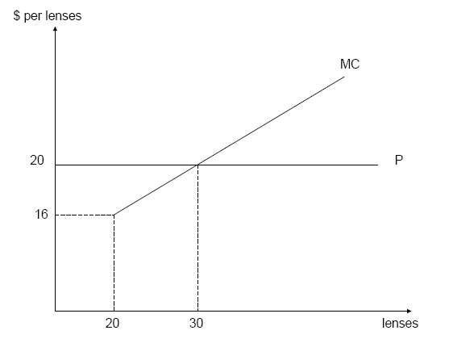

1. In your diagram for part (a) illustrate the daily profits of the typical lens grinder.

***Bonus*** Suppose the production function for a firm is given by f(L,K) = (LK)1/4 and the input prices are given by w = 10 and r = 2.5. Use the Lagrangian method to find the compensated factor demands for L and K and the value of the Lagrange multiplier (as a function of Q). Use the compensated factor demands to find the variable cost curve and the marginal cost curve. Compare your answer for the marginal cost and the Lagrange multiplier What do you notice?

**Answer:**



From these first order conditions, we can get



The variable cost is





The marginal cost is equal to the Lagrange multiplier.